**PRESENTATION OF DEVELOPED SOFTWARE ARCHITECTURES/MODELS FOR THE INTEGRATED DATA MANAGEMENT SYSTEMS FOR GIZ-SEDIN TO EASE CAPTURING, MANAGEMENT, AND STORAGE OF MSMES MONITORING DATA FOR PROGRAMME USE.**

**Background information**

The objective of the Pro-Poor Growth and Promotion of Employment in Nigeria - SEDIN Programme of the Deutsche Gesellschaft für Internationale Zusammenarbeit (GIZ) is to increase sustained employment and income generation in MSMEs. The target groups of SEDIN are the owners and employees of MSMEs as well as members of other economically active low-income households.

To deepen its interventions, the GIZ-SEDIN programme wishes to focus on institutional support to MSMEs, business advocacy groups and strengthening of local support systems such as cooperatives and business membership organisations in the provision of business-related services to MSMEs. This will involve the engagement of partner and beneficiary organisations in the provision of tailor-made services to the individual MSMEs.

These organisations are expected to also support in the provision of feedback and monitoring data to the programme. Thus, an effective data management system with a functional monitoring database that integrates the programme monitoring data from the various organisations would be required. To this end, SEDIN has engaged Ironet Ventures, an IT firm to develop an integrated data management system to automate the process of data capture, management, and retrieval for some of its interventions.

**Objectives of the Assignment**

The objective of the assignment is to develop an integrated data management systems for SEDIN to ease capture, management, and storage of MSMEs monitoring data for programme use.

**Organisation and methodology**

The assignment is to be implemented in the following stages:

**Stage1:** onboarding of the consultants by the SEDIN M&E team and relevant technical team members and review of relevant programme documents relating to data flow (capture, management, and storage) and interactions with selected partner organisations on data needs and uses.

**Stage2:** development and presentation of integrated data management design/model for the programme and review with the M&E team.

**Stage3:** actual development of the data management system- this includes the development and deployment and launch of the system and onboarding of M&E team on its use.

**Stage4:** system test-run and review. It will also include review of challenges encountered during test-run and system review to mitigate challenges.

**Stage5:** finalization of system, training of users and handover. This stage will also include report writing on the assignment.

So far, Ironet Ventures has successfully gone through the first of the assignment; the outcomes of the set of activities including field trip, virtual meetings, and reviews of relevant SEDIN documents is outlined below.

**Onboarding Meeting**

The team of experts from Ironet ventures had an onboarding meeting with the SEDIN M&E team including the Mr. Nosa Obayuwana, Mr. Steven Adeboye and Mrs. Deborah Olayemi to understand the challenges they face in the capturing, processing, and retrieval of monitoring from the partner and beneficiary organisations.

**Field Visits to Lagos and Ogun State**

The Ironet ventures’ team also paid visits to selected Partner Organisations (POs) of the SEDIN programme under the GOPA1 and GOPA 2 teams in Lagos and Abeokuta. The team met with …. Selected POs over 3 days to have a better understanding of the current process of data capture and management to get firsthand information about the challenges they have in data management.

**One on One virtual Meeting Mr. Nosa Obayuwana on Value Data Management**

Lastly, the Ironet team had a virtual meeting the SEDIN M&E Advisor, Mr. Obayuwana on the data collection and management requirements in the SEDIN value chain intervention. A sample of the value chain database template was shared with the team.

**Our understanding of the process of data capture, management, and challenges**

From the foregoing interactions, below is our understanding of the process of data capture and management and the current challenges.

* GIZ-SEDIN programme provides institutional support to MSMEs, business advocacy groups and strengthening of local support systems such as cooperatives and business membership organisations in the provision of business-related services to MSMEs.
* GIZ-SEDIN M&E team use the (POs) to carryout capacity development through training in four module which include inspire, create, start and, scale- up module for MSMEs, young graduate, returnees and many others.
* GIZ-SEDIN have 26 POs which spread across 3 state include Niger state, Ogun state and Plateau state. In Ogun State there are 10 POs, and Ogun is used as a Pilot. In this region only 3 modular courses which include create, start and the scale module are in operational. The targted goal is 10 thousand participants
* M&E use Kobo instrument to capture data from benefitciaries through their (POs) across two states with five in Lagos and five in Ogun state
* The beneficiaries category include returnees from different countries but key attention are paid to returnees from Germany, others are IDP, PWUD, under-graduate, young entrapreneure. 30% of the beneficiary are women and they are between the ages of 18 to 35 or 40 years.
* The (POs) train the beneficiaries in modules for inspire module, how to prepare good CV, answer interview questions and the deliverables include presentation of good CV. For create module they are trained on how to develop a bussiness ideas, how to prepare bussiness model canvas (BMC) and the deliverables is presentation of BMC. For Start module the beneficiary include those with no bussiness registration ( i.e no CAC registration), no SON, no NIN, no TIN, no cooperate bank account, no NAFDAC registration but have business model canvas, they are trained on how to start a bussiness by training them on how to write bussiness plan and after which they are assisted for registration of CAC, TIN, SON, , NIN, and facilitate their NAFDAC registration. The expected delivearables include access to finance. However, for Scale-up module they are train on how to grow their bussiness, the delivearble is employment creation and income generation.
* The monitoring data for the scale up is the numbers of persons employed, their profit, the baseline are gotten. They have check list for this accessment.
* Each of the module is not necessary a prerequisite for another module
* **The data flow process:** The Pos do adverts and then give their beneficiary special app link to capture the beneficiaries data. They have access to the back end of this link through kobo tool to see number of applicants applied, their phone number, mail and other details.

Base on these details, the POs select and categorize qualified applicant ( their beneficiaries) for different training module. The POs have the right to place these beneficiaries in what ever module they deem fit. The beneficiaries are given orientation and brief about the outcome of the different modules. Then the training starts (general skill accessment); the inspire module has 10 days for both physical and online classes: 2 days for physical class, 7 days for online classes and the last day for interview. After the trainning the beneficiaries go through post assessment test 6months and one year later for all the module. The data are capture using kobo tool and migrated to ms team for centralized storage. There is centralized database for all the POs. The M&E can see all the data belonging to all the

POs while the POs can only see their individual dataset. Using only different link to acess the database

**Challenges:** The various challenges experienced by the POs and M&E team in the use of previous system are highlighted below:

* The post assessment form is elongated and bucky, this usually discourage the beneficiaries for filling the form.
* Some applicants apply for POs not in their recident and consequently the M&E find it difficult to place the beneficiaries under the right POs.
* Most applicant have poor understanding about the whole process some chose moduls they are not qualify for. Consequently the POs do more work to reallocate the applicants.
* The general questions ask at application level are too many but they are essential. How do we solve the problem without increasing or reducing the number of questions.

1. **Statement of the problem**

The various concerns highlighted are broken down into the various sections highlighted below:

*Partner Organisations (PO)*

The PO’s desire to see only beneficiaries registered under them

The P. O’s want to have control over the beneficiaries registered under them

*Monitoring and Evaluation (M & Es)*

The M & Es desire to see only beneficiaries and POs registered under their zones

The M & Es want to have better monitoring of P.O’s under them

*Beneficiaries (M & Es)*

Beneficiaries must have access anytime and at any location to fill their respective forms

Beneficiaries must be able to fill the forms easily and without ambiguity in the questions asked

*Admin*

Admin must have access to the entire database and all information.

**Our proposal to mitigate the challenges and problems**

Decoupling the entire system into separate logical concerns (Phone or Desktop Applications) for each participant (PO, M&E, Admin, Beneficiaries). This would handle these issues raised.

This is presented in the Software Architecture adopted for the design see Section 1 below.

**SECTION 1: INTEGRATED DATA MANAGEMENT SYSTEM (IDMS) DESIGN/MODELS DESCRIPTION** (Please refer to the Figure 1)

**The description of Software Architecture/Model for IDMS is outlined as follows:**

* All clients are connected through various APIs to the database.
* Each Client (PO, M&E, Admin, Beneficiaries) has their own app decoupled from the SEDIN Website(s) where beneficiaries can apply and are placed on different packages/programmes.
* The process is decoupled immediately after a beneficiary applies. If his(her) application is accepted, he (she) is given an ID to login to a downloaded app where his assessment is carried out through each of the Apps outlined below. The ID provides the link among the different beneficiary app packages.
* The P.O’s have their own app which they can use to access the system and create their information, view their created information, and view ONLY beneficiaries’ data directly registered under them.
* The M & M&E’s have their own app that they can use to access the system and create their information, view their created information, and view ONLY PO’s and beneficiaries under their own ZONES.
* The program Admin can view the OVERALL of all PO’s, M & M&E’s, and beneficiaries' data under all the various programmes.
* Solution: prevous system addressed this problem by using personalized links by the POs while M&E use differnt variables from their application form. use integrated database for all POs but with personalized links and the beneficiaries are given an ID at application stage that indentify them with their POs. The ID will be generated at the backgroung and given to the beneficiaries when they come for the trainning. The app will tell them the module they are qualify for
* to reduce the reallocation process the integrated system will use multiple verication process to preallocate the applicants and final allocation is done by the POs with the M&E at the back end.
* breaking the questions into two stages ( the base line questions and qualifying questions) using base line questions for selection before moving to other stage of the questions that qualifies them for any of the modul

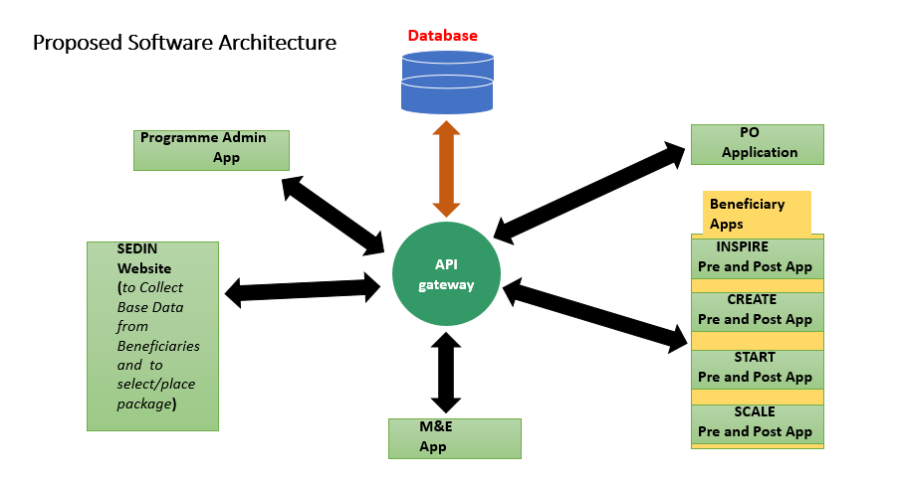

Figure1: Proposed Software Architecture

**SECTION II**

**Proposed Design Models and Software Requirements for Implementation**

Outlined below are two (2) models for your perusal and to make a specific choice in order for us to adopt, design, and implement.

**1: Design Model One (1) for GOPA1/GOPA2 – Pure Cloud Context**

This model is made up of basically 4 components:

Public Front–End, Cloud API Server, Cloud Database Server, and Public Back-End Admin as shown in Figure 2 below:

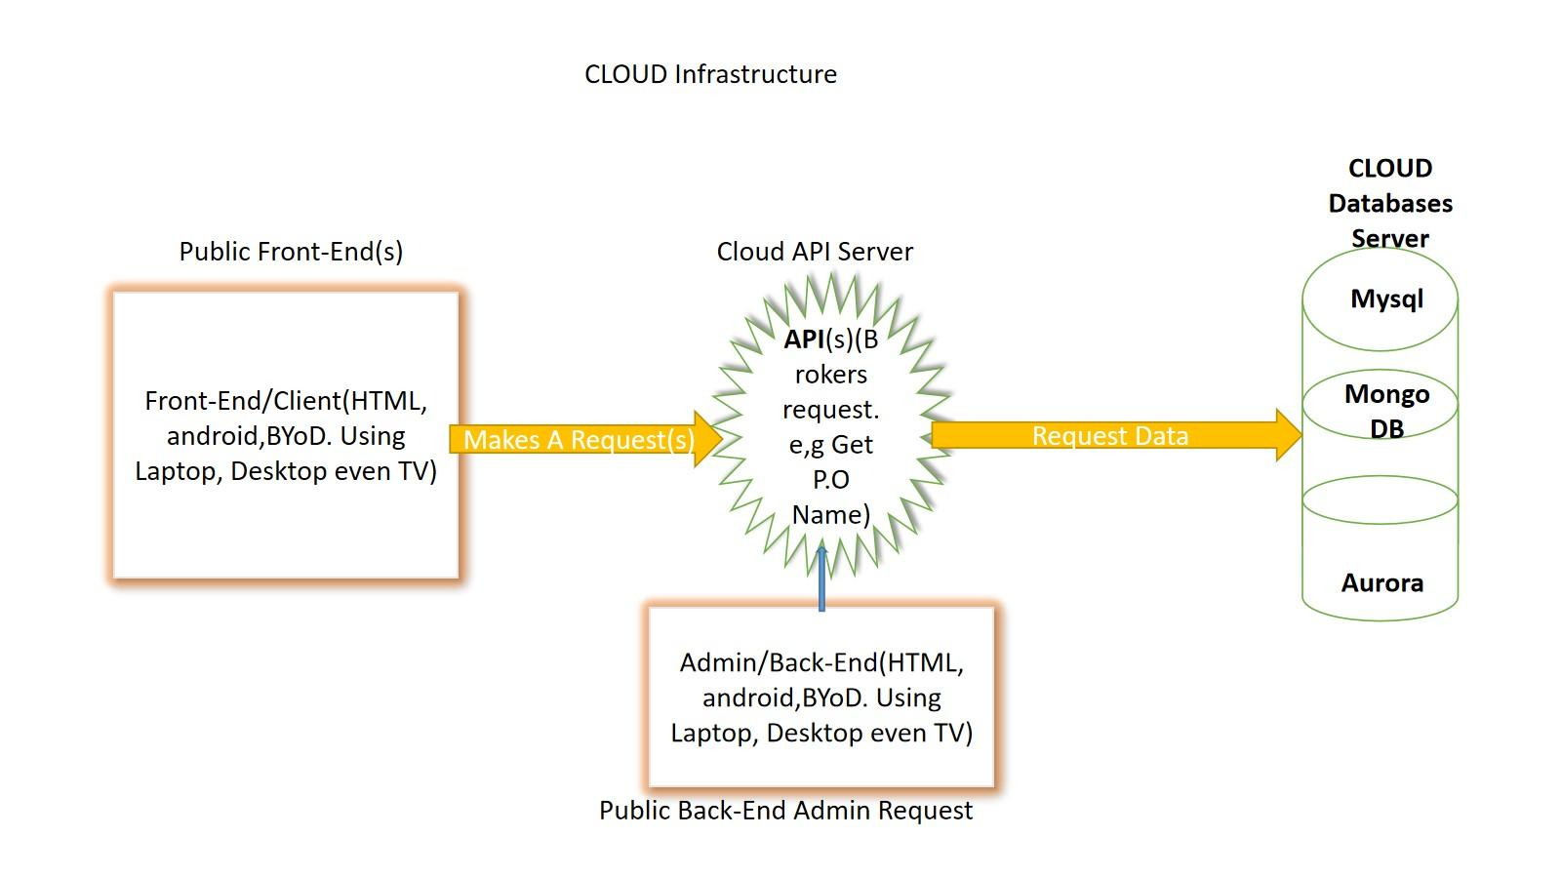

Figure 2: Model One for GOPA1/GOPA2

**Front-End:** The Front-End is cloud be any Device. The Front-End is where the clients, P.O and M.E have the first contact with the Software. The Idea is to “Bring Your Own Device”. Data is entered through the front end and viewed through the front It could be any of the following:

1. Laptops

2. Desktops

3 Web-Enabled Phones

4 Any web-enabled smart device

**Back-End:** Reports and sensitive data are viewed based on agreed-upon conventions. There is data that is meant for only P.O’s and data made available for M&E officers these should not be mixed.

**APIs:** This is where most of the logic is held. The APIs will be stored on cloud-based servers.

**Database:** This will hold the actual Data. We intend to use a robust and industry-tested database e.g Amazon Aurora**.** There will be at least two different types of database technology used, SQL and No-SQL.

**Errata:** Due to cost considerations some things have not been added to this model. This model does not take care of redundancy and High Availability. What does this mean? Well  one of this the problems is that if the database was to have issues, there may be no back-up

**Table1: Budget for Design Model-One for GOPA1/GOPA2**

|  |  |  |  |
| --- | --- | --- | --- |
| **S/N** | **DESCRIPTION** | **RATE (N)** | **AMOUNT (N)** |
| 1 | Cloud Server deployment Per Annum |  | **$4350** |
| 2 | Bandwidth Cost/Operational Cost |  | **$300** |
| 3 |  |  |  |
|  |  | **TOTAL** | **$4650** |

**2: Design Model Two (2) for GOPA1/GOPA2 programme**

This model is made up of basically 3 components:

Front-End, Back-End Admin, and Database Server: This will have the same cost implications as Design Model 1 with additional costs for setting up the various datacenter. The other component is the **State / Regional Data-Center Component**

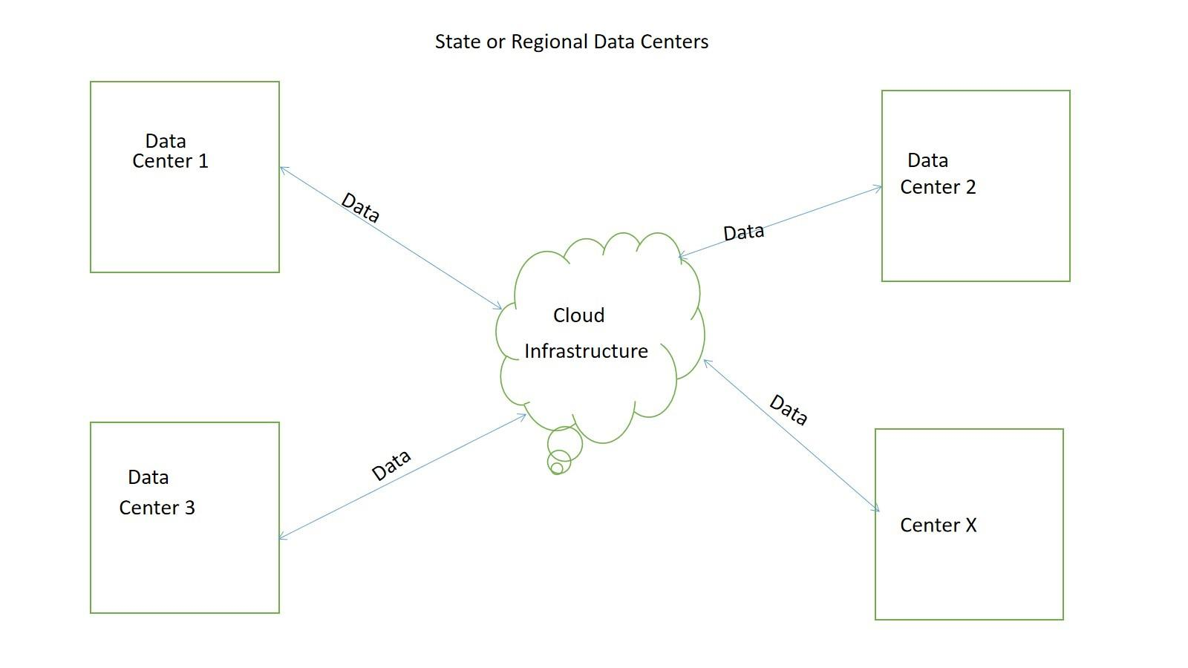

Figure 3: Model Two for GOPA1/GOPA2

**Note:** This component will require the following for each center and each region

1. Local Area Network Infrastructure
2. Internet Bandwith
3. A minium  of 2 servers
4. Auxiliary Software

These centers can push and pull data from the cloud centers as described in figure 4

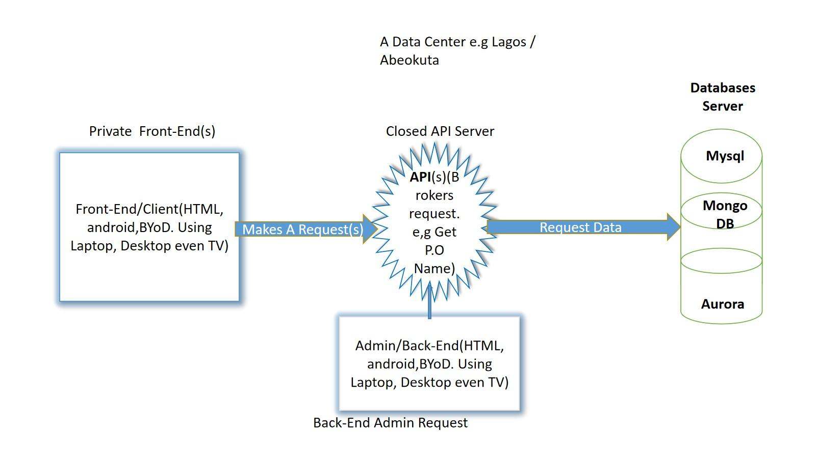

Figure 4: Data Center Description

**Table2: Budget for Design Model-Two for GOPA1/GOPA2**

|  |  |  |  |
| --- | --- | --- | --- |
| **S/N** | **DESCRIPTION** | **RATE (N)** | **AMOUNT (N)** |
| 1 | Cloud Server deployment Per Annum |  | **$4350** |
| 2 | Bandwith Cost/Operational Cost |  | **$300** |
| 3 | Data-Center Setup (This is a One-off Cost). |  | **$4500** |
| 4 | Cost of Power |  |  |
|  |  | **TOTAL** | **$9150** |

**Cons:** Data Centers will be replicated over the country, they will need power and physical security. They will need to be manned by staff.

**Pros:** Data is closer to the people who require it.

**ADDENDUM**

**LED Component**,

This component is treated as separate to keep things simple and for security concerns. The description of this model is the same as Design model 1 in Section ii and this will have the same cost implications as model one seeing Table 3 below.

**Table 3: Model cost for LED Component**

|  |  |  |  |
| --- | --- | --- | --- |
| **S/N** | **DESCRIPTION** | **RATE (N)** | **AMOUNT (N)** |
| 1 | Cloud Server deployment Per Annum |  | **$4350** |
| 2 | Bandwidth Cost/Operational Cost |  | **$300** |
|  |  |  |  |
|  |  | **TOTAL** | **$4650** |